SQL ASSIGNMENT-01: MURDER MYSTRY

Submission By

Name: SHIVAKUMAR

Reg N0: 2237019

Class: 2MAECO

Submission Date: 29-03-2023

Submitted to: Abdul Sir.



MA APLLIED ECONOMICS

DEPARTMENT OF ECONOMICS

CHRIST UNIVERSITY ( DEEMED TO BE UNIVERSITY)

MARCH 2023

1. Query no:1

select *

from crime_scene_report

where

type = "murder"

and city = "SQL City"

and date = "20180115"

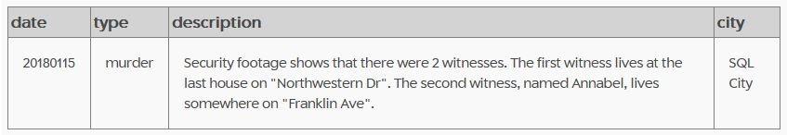

1. Query no:2

select

*

from person

where address_street_name

like "Franklin Ave%”

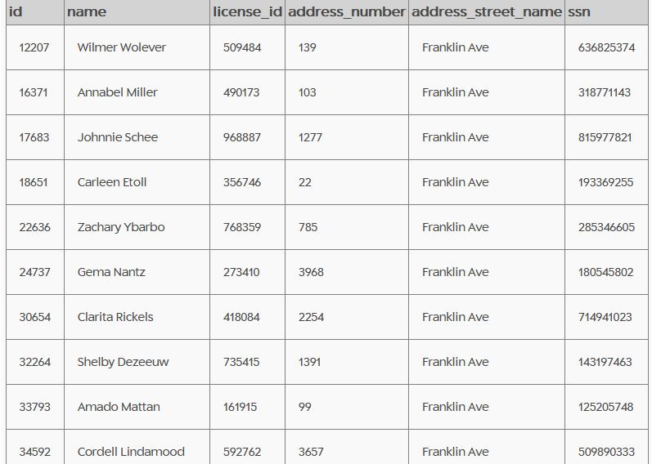

1. Query no:03

select

*

from person

where address_street_name

like "northwestern%"

order by

address_number DESc

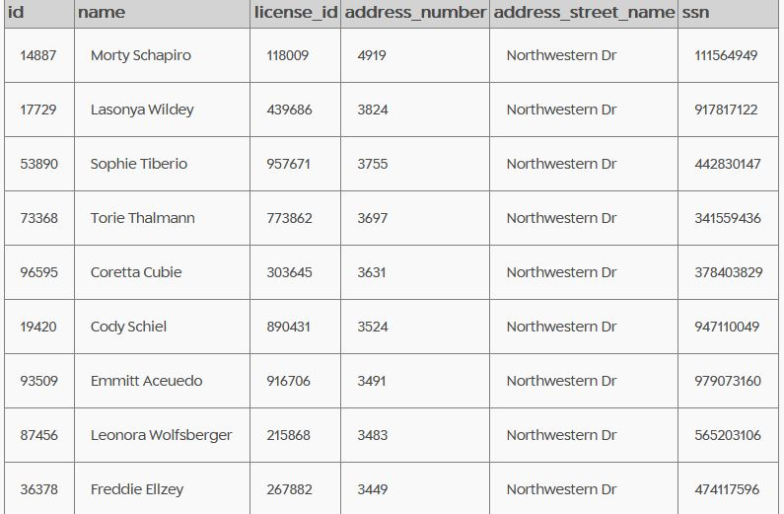

1. Query no:4

select

*

from interview

where person_ID =16371

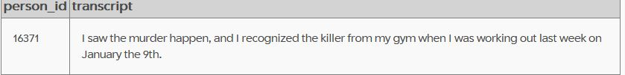

5)Query no:5

select

*

from interview

where person_ID =14887

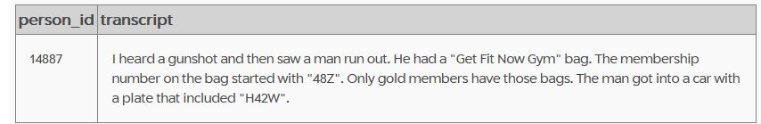

6)Query no:6

select

*

from get_fit_now_check_in

join get_fit_now_member

on get_fit_now_check_in.membership_id = get_fit_now_member.id

where membership_id

like "48Z%"

and check_in_date =20180109

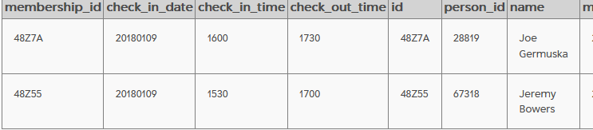

7)Query no: 07

INSERT INTO solution VALUES (1, 'Joe Germuska');

SELECT value FROM solution;

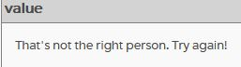

INSERT INTO solution VALUES (1, 'Jeremy Bowers');

SELECT value FROM solution;

